Mehmet Gülçen
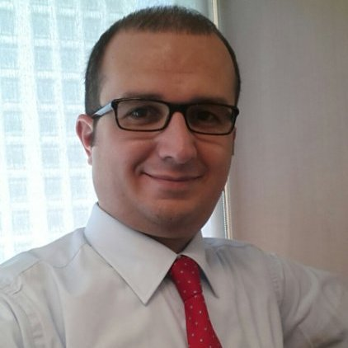

Personal Information

Birth Place / Date : Turkiye / March 9th,1976
Nationality : Turkish Republic
Driving License : EU
Marital Status : Married
Adress : Amstelveen, The Netherlands
Mobile Phone : +31.6.27837080
E-mail : mgulcen@yahoo.com

Education

2006 – 2008 : Bilgi University, Istanbul (Master’s Degree)
1993 – 1998 : Istanbul University, Economics in English
1990 – 1993 : Yalova High School, Trade & Accounting (graduated with honor degree)

Job Experience

01.2022 - Present : KEB Hana Bank Amsterdam
FI and Trade Finance

- Managing Hana Bank Amsterdam’s FI and transaction services business.

- Sales and marketing of trade finance products to commercial clients.

- Paying regular visits to existing and potential clients and offering them tailor-made
trade finance and cash management and working capital solutions.

- Having responsiblity for origination, negotiation and execution of TF transactions
including documentation and operational process.

- Managing whole credit process (proposal, utilization, monitoring, etc) for FIs and
trade finance clients.

- Handling KYC process for FI and commercial clients.

04.2017 - 12.2021 : ING Bank A.S. Turkiye
Financial Institutions, Syndications and Debt Markets

- Managing ING Turkiye’s FI, TF and debt markets business (as detailed below)

10.2016 - 03.2017 : ING Bank N.V. Netherlands
Transaction Services / Short Term Assignment

- Short term assignment in Transaction Services which provides support to ING offices throughout the world to capture transaction services businesses (trade finance, working capital solutions, payments and cash management, etc.) of international corporate clients.

10.2010 - 09.2016 : ING Bank A.S. Turkiye
Financial Institutions and Trade Finance

- Managing ING Turkiye’s FI and trade finance business.

- Paying regular visits to corporate clients and informing them about our bank’s trade finance, cash management and debt markets capabilities which fit their financing needs and cash flows.

- Arranging and providing structured trade loans for corporate clients from the international markets.

- In line with our bank’s funding policy, managing processes including documentation to obtain funding (such as syndication, securitization, covered bond, etc).

- Sales of loans (syndication, project finance, trade finance, etc.) in the secondary market.

10.2006 - 09.2010 : ING Bank A.S. Turkiye
Client Coverage – Multinational Clients / Senior Manager

- Sales and marketing of wholesale banking products to multinational clients.

- Making credit assessments for the clients and presenting credit proposals to loan committees.

- Monitoring economic developments throughout the world and preparing sectoral reports.

- Providing consultancy to the clients about local and global economy.

08.2000 – 09.2006 : Yasarbank-Sumerbank-Oyakbank / Senior Credit Auditor, Turkiye

- Conducted regular audit and inspection on all kind of loans (corporate, commercial, SME, retail, project finance, etc.) and processes.

Foreign Languages

English (Advanced), Dutch (B1)

Trainings

Attended various courses and seminars in Turkey and abroad.

Certificates

Loan Documentation (2020) - In Depth as per Loan Market Association (LMA) - Sue Wright on line course

References

Available upon request.

